**HTML5 New Form Attributes**

HTML5 added the following attributes for <form>:

* autocomplete
* novalidate

**Attribute = autocomplete**

The autocomplete attribute specifies whether a form or input field should have autocomplete on or off.

When autocomplete is on, the browser automatically completes the input values based on values that the user has entered before.

Tip: It is possible to have autocomplete "on" for the form, and "off" for specific input fields, or vice versa.

The autocomplete attribute works with <form> and the following <input> types: text, search, url, tel, email, password, datepickers, range, and color.

**Example:**

**<form action="/action_page.php" autocomplete="on">**

**E-mail: <input type="email" name="email" autocomplete="off"><br>**

**<input type="submit">**

**</form>**

**Output:**



## **New(ish) in HTML5**

The autocomplete attribute was introduced as an unofficial HTML feature in Microsoft's Internet Explorer, and was adopted by a number of other browsers. So there has been wide support for it for a long time, although its exact behavior wasn't standardized. With HTML5, the autocomplete attribute is an official part of the specification.

## 

## **autocomplete vs. list & <datalist>**

The autocomplete attribute asks the browser to attempt auto completion, based on user history. This is useful for personal details like name and email address — things the user is likely to have types into similar input fields on other web sites. The autocomplete feature is *not* able to provide the browser with a list of site-specific autocomplete options. For autocomplete behavior with site-specific suggestions, use the [list](https://html.com/attributes/input-list/) attribute with the [<datalist>](https://html.com/tags/datalist/) element.

## 

## **Autocomplete and name**

Browsers use the [name](https://html.com/attributes/input-name/) attribute in order to figure out what type of information an input field is asking for. So use standard, meaningful values for name. If you are asking for an address, use names like:

* address-1
* address-2
* city
* state or province
* zip or postal-code

Don't use clever or oddly specific names, as that makes it harder for the browser to provide autocomplete suggestions, and it can even lead to the browser trying to fill in the wrong values

**Type=novalidate**

The novalidate attribute is a <form> attribute.

When present, novalidate specifies that the form data should not be validated when submitted.

**Example:**

**<form action="/action_page.php" novalidate>**

**E-mail: <input type="email" name="user_email">**

**<input type="submit">**

**</form>**

**With the same program without novalidate attribute you would have got the following Output:**

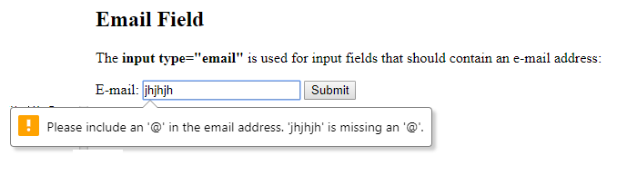

**Output With novalidate**



**Here the form will get submitted without validating the text**

**References**

**https://html.com/attributes/input-autocomplete/**

**https://www.w3schools.com/html/html_form_attributes.asp**